

**Software Requirement Specification (SRS) Conference Directory Portal**

**Prepared for**

**Dr. Nazar Zaki**

UAE University

# 1 Revision History

|  |  |  |  |
| --- | --- | --- | --- |
| **Date** | **Description** | **Author** | **Comments** |
| 14/11/2016 | 1.0 | Prashant Thomas | Initial version |
| 17/11/2016 | 2.0 | Prashant Thomas | Modified version |
| 21/11/2016 | 3.0 | Prashant Thomas | Modified version |
| 22/11/2016 | 4.0 | Lekshmi Krishna | Final version |

# 2 Document Approval

The following Software Requirements Specification has been accepted and approved by the following:

|  |  |  |  |
| --- | --- | --- | --- |
| **Signature** | **Printed Name** | **Title** | **Date** |
|  | Dr. Nazar Zaki | Department Head (Computer Science and SW Engineering) |  |

# Table of Contents

**1** **INTRODUCTION 1**

## 1.1 ENGAGEMENT CONTEXT 1 1.2 PURPOSE 1 1.3 SCOPE 1 1.4 THIS DOCUMENT AND ITS STRUCTURE 2

**2** **GENERAL DESCRIPTION 3**

## 2.1 USER CHARACTERISTICS 3 2.2 GENERAL CONSTRAINTS 3 2.3 ASSUMPTIONS AND DEPENDENCIES 3

**3** **REQUIREMENTS IN DETAIL 4**

## 3.1 SOFTWARE INTERFACE REQUIREMENTS 4

3.1.1 USER INTERFACE – WEB 4 3.1.2 COMMUNICATIONS INTERFACES 4

## 3.2 FUNCTIONAL REQUIREMENTS 4 3.2.1 SYSTEM REQUIREMENT 4

3.2.1.1 Authentication and Authorization 4

3.2.1.2 Auditing and logging 5

3.2.1.2.1 Logging 5

3.2.1.2.2 Auditing 5

### 3.2.2 USER REQUIREMENTS 6

3.2.2.1 User Registration Basic 6 3.2.2.2 USER REGISTRATION Advanced 6

3.2.2.3 Search Window 7

3.2.2.4 Register the Conference 9

3.2.2.5 Edit Conference 11

3.2.2.6 Register for a conference 11 3.2.2.7 Conference Review 11

3.2.2.8 Upcoming Conference Notification Emails 12

3.2.2.9 batch Job for sending emails 12 3.2.2.10 Conference Archival 12

3.2.2.11 Conference Home Page 13

3.2.2.12 Admin Features 14

3.2.2.13 Conference Creator view of conference applicants / approvals 14

3.2.2.14 Email notification to conference organizer 14

**4** **NON FUNCTIONAL REQUIREMENTS 15**

## 4.1 HARDWARE REQUIREMENTS 15 4.2 LOGICAL DATABASE REQUIREMENTS 15 4.3 TECHNOLOGY STACK USED FOR DEVELOPMENT 15 4.4 PERFORMANCE REQUIREMENTS 16 4.5 SCALABILITY 16 4.6 DOCUMENTATIONS 16 4.7 RELIABILITY 16 4.8 AVAILABILITY 17 4.9 SECURITY 17 4.10 DATA STORAGE 17 4.11 ERROR EXCEPTION / HANDLING 19 4.12 USER INPUTS 19 4.13 USABILITY 19

**5** **ANALYSIS MODELS 20**

## 5.1 SOLUTION CONCEPT DIAGRAM 20 5.2 HIGH LEVEL ARCHITECTURAL OVERVIEW 21

5.2.1 APPLICATION ARCHITECTURE 21 5.2.2 TECHNOLOGY ARCHITECTURE 22 5.2.3 APPLICATION WORKFLOW 23

**6** **PROJECT & CHANGE MANAGEMENT PROCESS 23**

### APPENDICES 25

**A.1 – READING REFERENCES 25**

**1 Introduction**

# 1.1 ENGAGEMENT CONTEXT

UAE University contacted Verbat Technologies to join the “InfoShere” project and to serve as a partner and a sub-contractor. During the course of collaboration, Verbat decided to develop a Conference Management Web application. This document pertains to the development of the Conference Management Application.

# 1.2 PURPOSE

The document provides a detailed overview of the Conference Management Application software product, its parameters and goals. It also describes the project's target audience and its user interface, hardware and software requirements. It defines how our client, team and audience will see the product and its functionality; this step is to assist designers and developers in the software delivery lifecycle (SDLC - Agile) processes.

The document is organized into sections to detail the workflow of different stakeholders or users of the application.

# 1.3 SCOPE

The scope of this document is to describe the features of the Conference Management Application System.

There are two types of user entities accessing the application: ADMIN and USER. There is only one ADMIN login but many USER will exist (henceforth ADMIN and USER used in the document to differentiate the user classification).

A Conference is an event that is created by the USER for other USER(s).

The application will have the following core components:

* **ADMIN** Dashboard**:** The ADMIN Dashboard will have the following features

o Manage Registered Users

* + - Add/ delete user
    - Edit user registration form

o Manage conferences

* + - Edit form to create a conference (add/remove fields)
    - View list of conferences
    - View/Edit conference details
    - Approve/Reject conference
    - Review/ delete user’s review ( bad review)
* **USER Dashboard: The USER Dashboard (For Conference creator/ attendee ) will have the features below:**

o Search conference by category, title, city or country (basic search)

* + Advanced search based on category, title, city, rating, technical sponsors, start and end dates, paper submission deadline and type of event.
  + View conference as per search criteria o View detailed Conference page
  + o Login/Register to the portal
    - Manage Conference
      * Create new conference
      * Edit conference added by the user
      * View details of candidates who showed interest by using “Intend to attend” button for the conference added by the user
      * View the review comments and rating of the conferences added by the user
    - View conference list
    - View conference details
    - Show interest by using “Intend to attend” button and review conferences
    - Report Spam: Registered USER can report spam related to any conference registered on the portal by using “Report Spam” button provided in the detailed Conference page. Admin will receive notification via mail when a conference is being flagged as spam.
    - Update his/her profile

# 1.4 THIS DOCUMENT AND ITS STRUCTURE

The remaining sections of this document provide a general description, including characteristics of the users of this project, the product's hardware, and the functional and data requirements of the product. General description of the project is discussed in section 2 of this document. Section 3 gives the functional requirements, data requirements and constraints and assumptions made while designing the application. It also gives the user viewpoint of product. Section 3 also gives the specific requirements of the product. Section 3 also discusses the external interface requirements and gives detailed description of functional requirements. Section 4 is for supporting information.

## 2 General Description

Conference management application is a portal designed to facilitate the creation and management of conferences as well as the conference attendees. The primary purpose of the application is to encourage as many users as possible to register in the website. Registration allows registrants to get timely update and notifications on upcoming conferences based on various criteria’s. Information on upcoming conferences will be send to users based on their preferences (i.e. weekly, daily, monthly etc.)

# 2.1 USER CHARACTERISTICS

The primary stakeholders for the system for Phase 1 are:

* *ADMIN*: The purpose of the administrator would be to manage the users and approve conferences. Admin will have option to manage the master data.
* *USER*: There is a single user types who can able to create and attend conferences. The system does not make any distinction between conference creator and conference attendee.

# 2.2 GENERAL CONSTRAINTS

* System shall be efficient enough for multiple users (could be more than 500 at the same time) to search and view conference information simultaneously
* All conferences should be saved/archived in a database. No data will be deleted from the site during the archival process, but will be marked by an archival flag
* Users can search the upcoming conference & events.
* USER should have flexibility to go to or search past conferences & can also review them
* In the case linking previous conferences, organizer can only search the past conferences.

## 2.3 ASSUMPTIONS AND DEPENDENCIES

* There is no real distinction between a user and a conference creator (the conference creator can be a user)
* Conferences will be available for review after it has been completed
* Conferences can be reviewed by conference participants by following the link from the email (email sent by the portal requesting to write review)
* Conferences can also be reviewed by the USER from the user dashboard using “Review Button”. Please visit https://www.confiq.com/ , see if we can implement anything similar to this website for Review on dashboard.
* Client will provide banner images, sample logo design etc.
* Website will be responsive

**3 Requirements in Detail**

## 3.1 SOFTWARE INTERFACE REQUIREMENTS

3.1.1 USER INTERFACE – WEB

The web application shall be compatible with the latest versions of the leading web browsers such as Internet Explorer, Mozilla Firefox and Chrome by which user can access to the system. Technical implementation of the user interface shall be implemented using industry accepted tools, packages or languages like PHP, HTML5, CSS3, Code Ignitor etc. The user Interface will be composed of a “Home Page” and associated pages with appropriate forms for registering users and conferences etc.

3.1.2 COMMUNICATIONS INTERFACES

The Conference Management System shall use the HTTP (post 80) & HTTPS (port 443) protocol for communication over the internet and for the intranet communication will be through TCP/IP protocol suite.

## 3.2 FUNCTIONAL REQUIREMENTS

### 3.2.1 SYSTEM REQUIREMENT

System requirements refer to the requirements met by the core application.

#### 3.2.1.1 AUTHENTICATION AND AUTHORIZATION

|  |  |  |  |
| --- | --- | --- | --- |
| **REQUIREMENT**  **ID (RID)** | **DESCRIPTION** | **PRIORITY LEVELS** | **EFFORT**  **REQUIRE**  **D** |
| **(P1, P2, P3, P4)** | **(H,M,L)** |
| CMS 3.2.1.1.1 | User will be authenticated using an email and password | P1 | L |
| CMS 3.2.1.1.2 | Email validation will direct the user to the  following dashboards based on his role  Home Page | P1 | L |
| CMS 3.2.1.1.3 | User will be allowed to login 3 times. After the third unsuccessful attempt the user will be forwarded to a remember password and email page |  |  |

#### 3.2.1.2 AUDITING AND LOGGING

*3.2.1.2.1 LOGGING*

|  |  |  |  |
| --- | --- | --- | --- |
| **REQUIREMENT**  **ID (RID)** | **DESCRIPTION** | **PRIORITY LEVELS** | **EFFORT REQUIRED** |
| **(P1..P4)** | **(H,M,L)** |
| CMS 3.2.1.2.1 | Logging will be used to capture all exceptions generated by the system. The following information will be captured:   * Exception Name * Exception Description * Exception Module * Severity (Critical, Medium, Low) * Time Stamp   The exceptions generated should be viewable on the admin dashboard | P1 | M |

*3.2.1.2.2 AUDITING*

|  |  |  |  |
| --- | --- | --- | --- |
| **REQUIREMENT**  **ID (RID)** | **DESCRIPTION** | **PRIORITY LEVELS** | **EFFORT REQUIRED** |
| **(P1..P4)** | **(H,M,L)** |
| CMS 3.2.1.2.2 | Audit logs will be generated for actions that are determined to be worth of investigating for security purposes. Information captured includes   * Logged in User * Time stamp * Application component accessed | P1 | H |

3.2.2 USER REQUIREMENTS

#### 3.2.2.1 USER REGISTRATION BASIC

|  |  |  |  |
| --- | --- | --- | --- |
| **REQUIREMENT**  **ID (RID)** | **DESCRIPTION** | **PRIORITY LEVELS** | **EFFORT**  **REQUIRED**  **(H,M,L)** |
| **(P1, P2, P3, P4)** |
| CMS 3.2.2.1 | Customers register on the website with a valid email address, password   * Email Address* will be of the format abcd@abc.com * Password*: minimum 8 characters composed of alphanumeric characters (requested 2 times and should be the same)   **Validation (mandatory)**  Customer Identity will be verified by using email validation link send to the customer’s email address | P1 | L |

#### 3.2.2.2 USER REGISTRATION ADVANCED

|  |  |  |  |
| --- | --- | --- | --- |
| **REQUIREMENT**  **ID (RID)** | **DESCRIPTION** | **PRIORITY LEVELS** | **EFFORT REQUIRED** |
|  |  | **(P1, P2, P3,**  **P4)** | **(H,M,L)** |
| CMS 3.2.2.2.1 | User must register in the application to   * Register for conference * Create Conference | **P1** | **M** |
| CMS 3.2.2.2.2 | **Registration**   * Title* ( Drop down list of Prof., Dr., Mr, Miss, Mrs) * First Name* () * Last Name* () * Photo (photo or avatar) * Organization* (Drop down list of Academy, Industry, Government, Others-Specify)  Job Title* |  |  |
|  | * Field of Interest (drop down list of category and subcategory. Select a max of 5, from ALLconference website) , * Email* (prepopulate if registered) * City* * Country* (drop down list) * Password* (min 8 characters with numbers) * Confirm Password* * Accept terms & conditions* (tick) mandatory * Receive Notification emails(Upcoming conference, surveys & promotions): Check box* (mandatory) * Not a Robot* : Type something (mandatory) *Mandatory |  |  |

#### 3.2.2.3 SEARCH WINDOW

|  |  |  |  |
| --- | --- | --- | --- |
| **REQUIREMENT**  **ID (RID)** | **DESCRIPTION** | **PRIORITY**  **LEVELS**  **(P1..P4)** | **EFFORT**  **REQUIRED (H,M,L)** |
| CMS 3.2.2.3.1 | **Basic (quick) Search**  Basic search can be done using the following fields   * Conference * Category * country   The search field will be an autocomplete field that will drop down in a format similar to the picture below. | P1 | H |

|  |  |  |  |
| --- | --- | --- | --- |
| CMS  3.2.2.3.2 | **Advanced Search**  Advance search will be placed on the left side of the screen as a side panel. Advanced search consist of searching on filter criteria. Filter can be one of   * Keyword * Country * City * Rating * Technical Sponsors (IEEE/ACM etc.) * Conference Start and End Date * Registration start & end date * Abstract submission start & end date * Paper submission start & end date * Type of event ( drop down values : Conference, Exhibit, trade fair, Workshop, Congress, webinar, other) | P1 | H |
| CMS  3.2.2.3.3 | **List Conference ( in the same page as search page)**  List the conferences with the following information   * Searched on Keyword   Rows with following columns   * Conference title * Conference Short title * Logo * Start Date – End Date * Location : City, Country * Venue * Advanced Search options will be listed on the left pane of the List conference page.   Sample : <http://www.allconferences.com/search>   * The conference list can be ordered by Name and begin date | P1 | H |
| CMS  3.2.2.3.4 | **Conference Details**   * Example page : [http://www.allconferences.com/c/smartseceurope-2016-amsterdam-2016-november-29](http://www.allconferences.com/c/smartsec-europe-2016-amsterdam-2016-november-29) * Name of the conference , Conference Logo/banner (single   line)   * Organization * Venue (hotel address, city, state country) * Category ( breadcrumb style) * Event Start and End dates * Date of registration : Start and End Date * Early registration date and time * Email Organizer, Conference Web Site, Download info, Report spam ( all in a single line)  Conference Description | P1 | H |
|  | * Venue location address, link to location and map * Organization location address , Link (optional) * Keynote speakers (you can add keynote speaker) * Keynote Speaker Photo * Keynote speaker Bio * Sponsors (drop list) * Paper Submission date * Additional Info * Intend to attend button* ( Register for conference) * Rate this conference * Conference Rating (1-10) based on attendee review (similar to bookings.com) * **Report Spam button** * Register for conference * **Links to the previous Conferences** |  |  |
| CMS  3.2.2.3.5 | **Search By category**  Conferences will be listed based on categories and sub categories. In the search page, the main categories will be listed as links. The categories can be navigated to sub categories and conference events within sub categories. |  |  |

#### 3.2.2.4 REGISTER THE CONFERENCE

|  |  |  |  |
| --- | --- | --- | --- |
| **REQUIREMENT**  **ID (RID)** | **DESCRIPTION** | **PRIORITY**  **LEVELS**  **(P1..P4)** | **EFFORT**  **REQUIRED (H,M,L)** |
| CMS 3.2.2.4 | Conference registration can be done by any registered user. The details for conference registration are   * Conference Title* (120 Characters no space) * Conference Short Title*(40 char no space) * Type*: Drop down list (Conference, Exhibit, trade fair, Workshop, Congress, webinar, other) * Category* – up to 5 listings ( main and sub as in allconferences.com) * Conference Logo / Banner * Conference Description* * Conference main topics* ( 2000 char, Rich text, no space) * Location (city, country)* : Drop down for | P1 | L |

|  |  |  |  |
| --- | --- | --- | --- |
|  | country, text for city   * Venue : Text 120 char * Key note speakers (Can add multiple speakers) o Name of speaker   + Speaker Bio (1000 char no space)   + Photo * Conference Start date* - End Date * Registration Date* (start-end date) * Drop down* (Abstract, Paper, Tutorial, Special Session, Poster Submission)  Calendar Date* for one of the above. * Author Notification Dates* (From – To) * Submission Instruction* (Rich text 3000 char, no space) * Registration Fee and Instructions* (Rich text   2000 char, no space)   * Hosting Organization * Hosting Org Logo * Sponsor Name * Sponsor Logo * Program : PDF upload * Accommodations ( rich text, 2000 char, no space) * Visa & Travel info (rich text, 2000 char, no space) * Social Events : (rich text field 1000 char no space) * Exhibit Information : (rich text 1000 char no space) * Conference Website : URL * Images : Max 5 images * Previous meetings : URL link * Contact Information o Fax o Email   o Phone   * Additional Information (rich text 3000 char, no space)   registered user |  |  |

#### 3.2.2.5 EDIT CONFERENCE

|  |  |  |  |
| --- | --- | --- | --- |
| **REQUIREMENT**  **ID (RID)** | **DESCRIPTION** | **PRIORITY**  **LEVELS**  **(P1..P4)** | **EFFORT**  **REQUIRED (H,M,L)** |
| CMS 3.2.2.5 | * The conference creator can edit all fields of the conference except the conference title. * The conference creator may delete (no hard deletes- only soft deletes) the conference, if the conference o Has not been approved   o Conference is not live and soliciting participants | P1 | H |

#### 3.2.2.6 REGISTER FOR A CONFERENCE

|  |  |  |  |
| --- | --- | --- | --- |
| **REQUIREMENT**  **ID (RID)** | **DESCRIPTION** | **PRIORITY**  **LEVELS**  **(P1..P4)** | **EFFORT**  **REQUIRED (H,M,L)** |
| CMS 3.2.2.6 | * Users can register for a conference. * Users register for the conference by clicking the register button. | P1 | H |

#### 3.2.2.7 CONFERENCE REVIEW

Provide ratings (1-5) for the following

|  |  |  |  |
| --- | --- | --- | --- |
| **REQUIREMENT**  **ID (RID)** | **DESCRIPTION** | **PRIORITY**  **LEVELS**  **(P1..P4)** | **EFFORT**  **REQUIRED (H,M,L)** |
| CMS 3.2.2.7 | * Location of conference * Organization of the Conference * Quality of the presentations * Meals & Gala Dinner * Quality of the keynote speakers * Instructions provided to Authors and the paper submission process * Would you recommend this conference to fellow researchers? (Yes / No) * Have you received notification of acceptance / rejection of your paper on time? (Yes / No) * Your review of the conference (comments) : text * I agree to terms and conditions by submitting the review (Check Box) | P1 | M |

#### 3.2.2.8 UPCOMING CONFERENCE NOTIFICATION EMAILS

|  |  |  |  |
| --- | --- | --- | --- |
| **REQUIREMENT**  **ID (RID)** | **DESCRIPTION** | **PRIORITY**  **LEVELS**  **(P1..P4)** | **EFFORT**  **REQUIRED (H,M,L)** |
| CMS 3.2.2.8.1 | Users who are registered on the website will receive notification emails about upcoming conference based on predefined criteras   Users must have subscribed to receive notification emails | P1 | H |
| CMS 3.2.2.8.2 | Implied Requirement   * User shall have an option to select topics in which they may receive notification emails * Notification Period : Period of receiving notification emails (Daily, Weekly, bi-weekly, monthly) | P2 | M |

#### 3.2.2.9 BATCH JOB FOR SENDING EMAILS

|  |  |  |  |
| --- | --- | --- | --- |
| **REQUIREMENT**  **ID (RID)** | **DESCRIPTION** | **PRIORITY**  **LEVELS**  **(P1..P4)** | **EFFORT**  **REQUIRED (H,M,L)** |
| CMS 3.2.2.9 | * Registered users who meet the condition to receive emails shall receive emails * The emails are triggered by a batch job or daemon process that runs daily | P1 | H |

#### 3.2.2.10 CONFERENCE ARCHIVAL

Conference information and conference details of conferences older than 3 months shall be archived

|  |  |  |  |
| --- | --- | --- | --- |
| **REQUIREMENT**  **ID (RID)** | **DESCRIPTION** | **PRIORITY**  **LEVELS**  **(P1..P4)** | **EFFORT**  **REQUIRED (H,M,L)** |
| CMS 3.2.2.10 | * Option 1: Search always returns results for conferences younger than 3 months. ( makes query faster) * Option 2: Archive data older than 3 months. Implies the need for a separate archival job that needs to run daily. | P1 | H |

**3.2.2.11 CONFERENCE HOME PAGE**

Home page will have the following elements.

|  |  |  |  |
| --- | --- | --- | --- |
| **REQUIRE**  **MENT ID**  **(RID)** | **DESCRIPTION** | **PRIOR**  **ITY**  **LEVEL**  **S**  **(P1..P**  **4)** | **EFFOR**  **T**  **REQUI**  **RED**  **(H,M,L**  **)** |
| CMS  3.2.2.11 | * Logo (banner) * Sign Up (registration button or link) * Login (existing Users) * Social Media Links * Search for conference with autocomplete field.      * Conferences should be listed by category, location & dates * Distribution of conferences around the globe ( refer [http://apps.cytoscape.org/apps/pemeasure)](http://apps.cytoscape.org/apps/pemeasure) No of conferences per location & updated automatically * Other Info (menu) : About Us, Why GlobConf, Terms & conditions, Privacy policy, contact Us * All “contact Us” mails shall go to a separate dedicated email address * Submit a conference : registered users can submit a conference, else, they must register * Featured conference bar: List featured conferences based on ranking and dates (upcoming first , right side panel along the length) * Counter for number of registered users, conferences created, visitors ( available only to admin) * Horizontal menu on top: Home, Search Conferences, | P1 | H |
|  | Services, Submit a conference, Advertise, Help, Sign Up   Expandable conference categories and sub categories Ex  See <http://www.allconferences.com/>for examples of elements to be displayed. |  |  |

#### 3.2.2.12 ADMIN FEATURES

|  |  |  |  |
| --- | --- | --- | --- |
| **REQUIREMENT**  **ID (RID)** | **DESCRIPTION** | **PRIORITY**  **LEVELS**  **(P1..P4)** | **EFFORT**  **REQUIRED (H,M,L)** |
| CMS 3.2.2.12 | * Manage registered users (Soft delete, activate, deactivate ) * Approve / Reject conferences * View list of conferences * Edit user registration and conference submission form * Manage master entries including country, category, sub category etc. | P1 | H |

#### 3.2.2.13 CONFERENCE CREATOR VIEW OF CONFERENCE APPLICANTS / APPROVALS

|  |  |  |  |
| --- | --- | --- | --- |
| **REQUIREMENT**  **ID (RID)** | **DESCRIPTION** | **PRIORITY**  **LEVELS**  **(P1..P4)** | **EFFORT**  **REQUIRED (H,M,L)** |
| CMS 3.2.2.13 | Conference creator shall be able to see all the conference participants | P1 | H |

#### 3.2.2.14 EMAIL NOTIFICATION TO CONFERENCE ORGANIZER

When user signs up for a conference emails goes to self & the organizer

|  |  |  |  |
| --- | --- | --- | --- |
| **REQUIREMENT**  **ID (RID)** | **DESCRIPTION** | **PRIORITY**  **LEVELS**  **(P1..P4)** | **EFFORT**  **REQUIRED (H,M,L)** |
| CMS 3.2.2.1[1] | ❖ Email will be send to the conference organizer (creator) when a user shows interest by “Intend to attend” button. | P1 | H |

**4 Non Functional Requirements**

# 4.1 HARDWARE REQUIREMENTS

Since the application must run over the internet, all the hardware used must have the capability connect to the internet.

❖ **Web Server for Hosting** – Recommend a scalable and load balanced Amazon Cloud Server x 2 (multiple servers to allow maintenance and upgrades without downtime) with the minimum requirement as below (to start with).

When required, the cloud infrastructure offers flexibility to scale up individual servers and will also allow distributed deployment across multiple geographies.

Recommended primary server configuration:

* Memory – 8 GB o SSL Verisign o Processors: 4 Cores o HDD Quota – 500 GB
* Monthly Transfer (Bandwidth) – Based on usage

## 4.2 LOGICAL DATABASE REQUIREMENTS

A Relational Database Management System will need to be used to store application data. The strategy adopted is to implement the project using an Open Source RDBMS system (ANSI standards) and further migrate to Oracle / MSSQL when data volumes near the thresholds.

Technology Stack:

* Web Languages – PHP, CodeIgnitor, JQuery, HTM5, CSS
* Protocol and Ports - HTTP (80), HTTPS (443)
* Database – MySQL, with ANSI SQL schema for future Oracle migration
* Server – Apache
* Operating System – Linux

# 4.4 PERFORMANCE REQUIREMENTS

Performance is primarily subjected to internet bandwidth available to the devices used by the customer

Furthermore:

❖ Search results shall not take more than 10 seconds to return results

Performance requirements shall be achieved by archiving data more than 3 months old

# 4.5 SCALABILITY

The scalability requirements are concerned with the scalable issues of the system. The system should allow up to as many as customer sessions with proposed hardware. Amazon’s scalability options are what is recommended for hardware scalability for high-end traffic.

## 4.6 DOCUMENTATIONS

|  |  |
| --- | --- |
| **ITEM** | **RESPONSE/COMMENT** |
| **Project documentation requirements** | * Requirements document * Technical design document * Functional specification document |
| **Training**  **Requirements** | Training will be provided for installing (including application migration) and using the application for users if required |

4.7 **RELIABILITY**

Selected cloud/hosting service reliability clause gets applied for this section.

4.8 **AVAILABILITY**

Selected cloud/hosting service availably clause gets applied for this section.

## 4.9 SECURITY

Hardware and network security will be covered by the selected cloud/hosting service availably clause gets applied for this section.

* The system shall use secure sockets in all transactions that include any confidential customer information.
* The system shall automatically log out all customers after a period of inactivity.
* The system shall confirm all transactions with the customer’s web browser or mobile apps.
* The system shall not leave any cookies on the customer’s computer containing the user’s password.
* The system shall not leave any cookies on the customer’s computer containing any of the user’s confidential information.

## 4.10 DATA STORAGE

* The user interfaces shall never display a customer’s password. It shall always be echoed with special characters representing typed characters.
* The user interfaces shall never display a customer’s credit card number after retrieving from the database. It shall always be shown with just the last 4 digits of the credit card number.
* The system’s back-end servers shall never display a customer’s password. The customer’s password may be reset but never shown.
* The system’s back-end servers shall only be accessible to authenticated administrators.
* It is recommended to encrypt the back-end databases.

|  |  |
| --- | --- |
| **ITEM** | **REQUIREMENT** |
| **Handling Sensitive Data** | Insensitive data such as company name, documents processed, relevant dates, noncompliance data etc. could be stored in the database as plain text for phase 1.  User information such as roles assigned, name, personally identifiable information (such as email, DOB, Phone numbers, business information etc.) will be stored as encrypted text. Passwords will be encrypted. |
| **Security Threats**  **Prevention** | The application will be hosted on a web server that implements SSL (HTTPS). Passwords will be encrypted. Protection against SQL injection will be implemented  Protection against Cross browser hacks and cross site scripting (XSS) will be implemented. |
| **Access Control** | Access control for the application will be role based. Individual users will be authenticated with passwords and authorized to access different parts of the site depending upon assigned roles. |
| **HTTPS** | Application will support both HTTP and HTTPS. |
| **Passwords** | Passwords will be case sensitive, 8 characters long, consist of integers and alpha numeric characters. |
| **Changing Passwords** | User will be allowed to change password by providing his original password and typing the new password 2 times. |
| **Forgotten Passwords** | Forgotten passwords can be reset by providing an email address attached to the account. A token based link with expiry will be send to the email for reset of the password. |
| **User Profiles** | User profile could be enabled or disabled by the system admin. |
| **Multiple Logins** | Simultaneous logins of a customer from multiple clients will be discouraged until verified - TBC |
| **First-Time Login** | User will have to reset the password or will have to reset/set preferences. |
| **Session Time Out** | Once a user signs in, the user will remain logged in, unless the user intentionally logs out. - TBC |
| **Failed Logins** | User will be flagged for multiple login failures. Audit trail will be kept for user login/logoff attempts. |
| **Encryption Algorithm** | SHA-1 algorithm will be used for encryption of passwords.  (also for any other pieces of data that needs encryption needs to be identified) |

## 4.11 ERROR EXCEPTION / HANDLING

|  |  |
| --- | --- |
| **ITEM** | **REQUIREMENT** |
| **Reporting**  **Business Rule**  **Violations** | Application error messages will be logged as well as any violations |
| **Messages for failed business**  **rules** | The GUI will display appropriate meaningful error messages for application failures or when the application encounters a known error. |
| **Localization** | Since localization is not provided other than for English speaking users, all error messages will be displayed in English |

## 4.12 USER INPUTS

|  |  |
| --- | --- |
| **ITEM** | **REQUIREMENT** |
| **Special**  **Characters** | Special characters like (~,!@#$%^&*()_+|){`=-\/.,.><;:’”, &#16;} will be restricted to passwords. Note: Malaysian addresses commonly use ‘#’ and  ‘/’ |
| **Auto-Generated**  **IDs** | Auto generated ID’s will be used within a database context. Passwords may be auto generated for the user. |
| **Boundary Conditions** | Birth year values should be checked for boundary conditions. |
| **Character Length** | Passwords (min length 8), usernames (length>8 && <15), emails (xx@xxx.xxx) should be checked for character length. A check should be provided for source document length (> xxx characters & < xxxxx characters as an example) |

## 4.13 USABILITY

|  |  |
| --- | --- |
| **ITEM** | **REQUIREMENT** |
| **Documentation** | User manuals and other relevant documents will be provided. |
| **Time Zones** | The prototype application will have UAE Standard Time as its time zone. Time zones cannot be configured in the current version of the application. Where ever applicable system date and time will be used to represent logical/business/calendar dates. |
| **User Interface** | The application developed will be best viewed in the resolution 1280px by  768px. The application will be responsive and will be available for mobile |
|  | devices as well as on a desktop web browser |
| **Tab Sequence** | Forward and backward tab sequences will be maintained in the form. |
| **Transactions** | Transactions will be ACID (Atomic, Consistent, Isolated and Durable) where required. |

**5 Analysis Models**

# 5.1 SOLUTION CONCEPT DIAGRAM

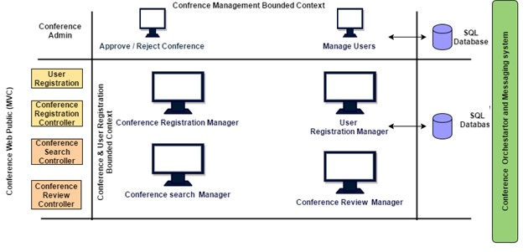

The diagram depicts the application compartmentalized based on the user profiles namely the admin and conference creator and conference attendee (the application does not make a distinction between the two). The different functions of the application are modularized to handle just that.

# 5.2 HIGH LEVEL ARCHITECTURAL OVERVIEW

## 5.2.1 APPLICATION ARCHITECTURE

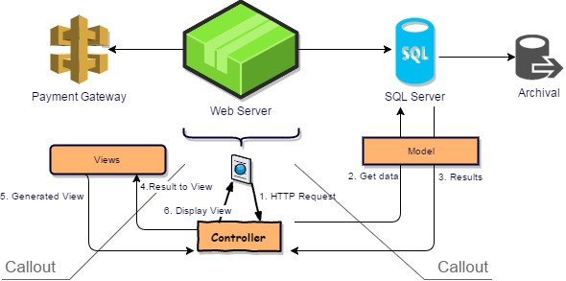

The application architecture depicted above contains a web server that PHP over Apache (Linux). The PHP code Ignitor framework will used to contain the Model-View-Controller (MVS) framework.

The web server communicates with an SQL (mySql) server. All data related to conferences older than 3 months will be archived to increase the scalability of the application. The web

server will also communicate with a payment gateway where users may make financial contributions (donations).

## 5.2.2 TECHNOLOGY ARCHITECTURE

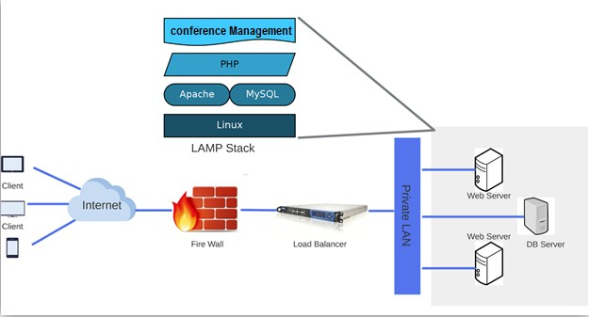

The diagram above depicts the network topology as well as the physical architecture of the application. The physical components of the web server is shown as a blow up (The application developed using PHP and CodeIgnitor sitting over Linux web server and connecting to a mysql server)

## 5.2.3 APPLICATION WORKFLOW

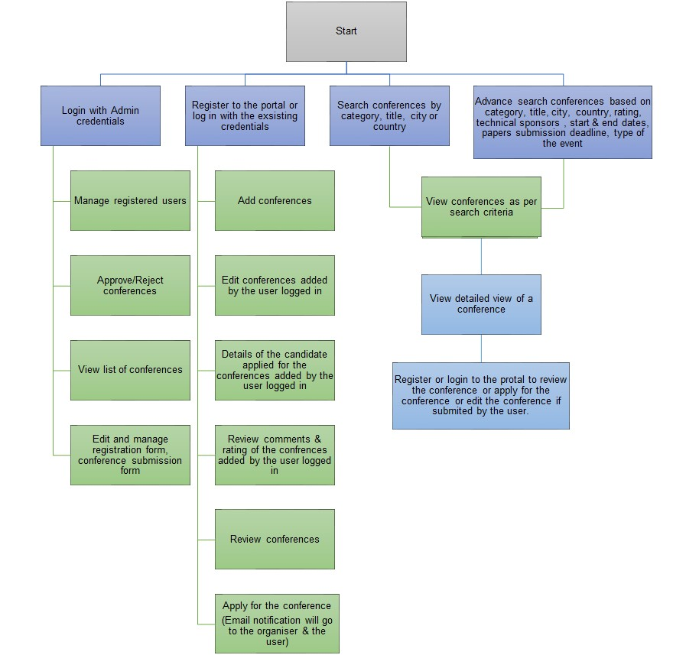

## 6 Project & Change Management Process

Disciplined Agile Delivery (DAD)'s approach will be used for project management. DAD is an extension to the Agile Scrum methodology’s approach to requirements management. Where Scrum treats requirements like a prioritized stack called a product backlog, DAD takes it one step further to recognize that not only do you implement requirements as part of your daily job but you also do non-requirement related work such as take training, go on vacation, review products of other teams, address defects and so on. With this approach the software development team has a stack of prioritized and estimated work items, including requirements, which need to be addressed - Programmers will have a stack of user stories written on index cards whereas DAD might use a defect tracker like JIRA to manage the stack.

Stakeholders are responsible for prioritizing the requirements whereas developers are responsible for estimating. The priorities of non-requirement work items are either negotiated by the team with stakeholders or are addressed as part of slack time within the schedule.

DAD WORKITEM STACK REPRESENTA

TION

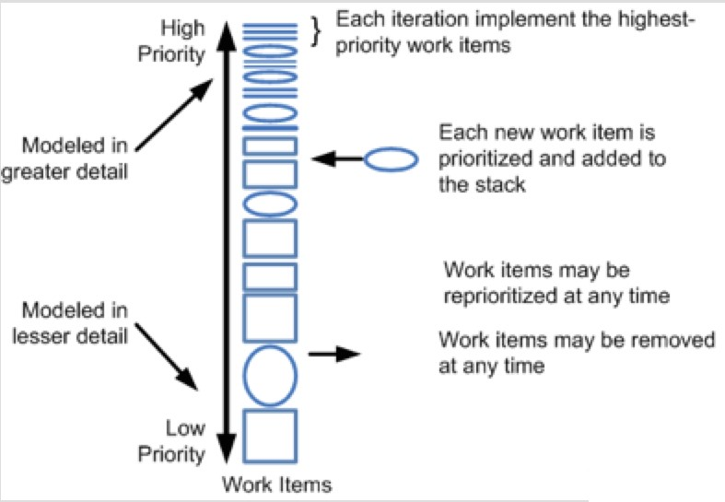

**Appendices**

## A.1 – READING REFERENCES

Following documents and URL’s were referenced from which the requirements were derived

❖ [www.allconferences.com](http://www.allconferences.com/)

1. .3 **TECHNOLOGY STACK USED FOR DEVELOPMENT**

   Technology Specifications for the project are specified below